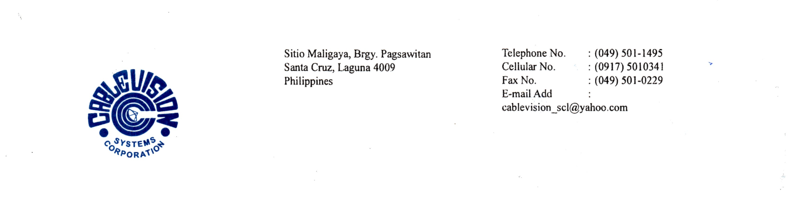

OCTOBER 2025
Dear Subscriber:

Greetings from Cablevision! We would like to inform you that by OCTOBER 2025, our Cable/Internet system will fully migrate to FIBER TO THE HOME. With this migration, all our TV Channels in ANALOG Format will be converted to DIGITAL Format.

In the process of migration, we need to install equipment that will be connected to your TV set. Thus, the following adjustments/guidelines will be made with regards to the transfer:

- A FREE TO USE MODEM and a SET UP BOX will be provided to each subscriber.
- Each SET UP BOX is good for one (1) TV Set Only.
- Any or Each TV Extension will need a SET UP BOX. There will be no additional fee on the monthly dues but the cost of the SET UP Box or boxes installed for each TV extension will be for the account of the subscriber.
- The subscriber should provide their own UTP cable for additional TV extensions that will be installed.
- All equipment that will be installed in the subscriber premise will have a one (1) year warranty only. Any defect on the equipment due to mishandling by the subscriber within the one (1) year warranty will be charged to the subscriber.
- All FREE TO USE EQUIPMENT installed to the subscriber premise are property of CABLEVISION SYSTEMS CORPORATION. Thus, said equipment will be pulled out upon termination of service contract with the company.
- Channel Line Up will be different from the current.
- ALL PROVISIONS ON THIS LETTER WILL FORM PART OF THE ORIGINAL CONTRACT.

THE MANAGEMENT

CONFORME: _______________________
Subscriber Name & Signature
DATE : _______________________

